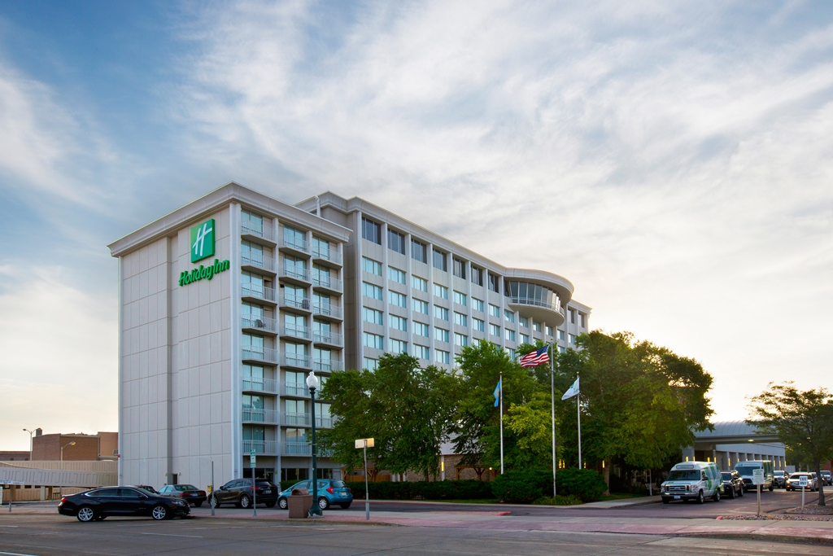
South Dakota Association of Nurse Anesthetists
2020 Annual Fall Education Conference

September 12-13, 2020
Holiday Inn City Centre
Sioux Falls, SD

Promote your business in front of Certified Registered Nurse Anesthetists across the state for the Spring Education Conference. If you have questions, please email us contactus@sdana.com

Installation of Exhibits
You may register on site with the SDANA registration desk:
6:00-7:00 pm Friday, September 11
8:00-8:30am Saturday, September 12

Removal of Exhibits
Removal must be completed by 6:00 pm on Saturday, September 12 unless prior arrangements have been made.

Exhibit Hours
There will be two half hour breaks on Saturday, September 12 designated specifically for exhibitors. During the first break you will be allowed the opportunity to give a three minute Exhibitor Elevator Pitch to all attendees.

Prizes
Exhibitors are encouraged to have drawings. Prizes may be a product or service offered. It must be usable by the winner without the purchase of additional goods
or services. Exhibitors are responsible for distribution of prizes.

Booth Specifications
- 1 complimentary 6’ skirted table and two chairs
- Access to electricity is available. Higher voltages will require special handling. Advance arrangements and charges are the exhibitor’s responsibility and expense.
- Extension cords, power strips, etc. are also your responsibility.
- Subletting or dividing exhibit space is not allowed except by permission of exhibits chairperson.
- Distribution of materials and displays is limited to booth space purchased.

Booth Cancellation
A refund (minus $25 processing fee) will be issued prior to September 4. No refunds after that date.

Program Support Opportunities

Friday Night Break: $600
- Signage at Event
- Identified as sponsor in handouts
- Recognized as sponsor during the event

Saturday Morning Break: $500
- Signage at Event
- Identified as sponsor in handouts
- Recognized as sponsor during the event

Saturday Luncheon: $1,200
- Signage at Event
- Identified as sponsor in handouts
- Recognized as sponsor during the event

Saturday Afternoon Break: $500
- Signage at Event
- Identified as sponsor in handouts
- Recognized as sponsor during the event

Sunday Brunch: $750

- Signage at Event
- Identified as sponsor in handouts
- Recognized as sponsor during the event

Hold Harmless Clause
“The exhibitor assumes the entire responsibility and liability for losses, damages, and claims arising out of exhibitor’s activities on the Hotel premises and will indemnify, defend, and hold harmless SDANA and its management company as well as their respective agents, servants, and employees from any and all such losses, damages, and claims.” SDANA will not be responsible or liable for any loss, damages or claims arising out of exhibitors activities on the hotels premises for any claims, loss, or damage arising directly from the SDANA’s own negligence.
Due to the layout of the hotel, storage space is not available for display materials and / or show merchandise. At the conclusion of the set-up operation, all related equipment, crates, trash, etc. must be removed from the premises.

Registration Form

Company / Organization __________________________________________________________________________________

Type of Exhibit _________________________________________________________________________________________

Address ________________________________ City / State / Zip _________________________________________________

Phone ______________________ Contact Person ____________________________________________________________

Email Address ___________________________________ Electricity? Y N

On-Site Main Contact Name ________________________________________________________________________________

Phone _______________________________ Email ____________________________________________________________

Second Representative Name _______________________________________________________________________________

Exhibit Booth Space: ____ $400 for 1st booth ____ $150 for additional booth

Support: ____ $600 Friday Night Break ____ $500 Saturday Morning Break ____ $1,200 Saturday Luncheon

____ $500 Saturday Afternoon Break

Total: ________________ (check enclosed)

Register online with credit card or send form and payment to:
SDANA, 617 Stumer Road, Rapid City, SD 57701 Tax ID: 46-6036687

