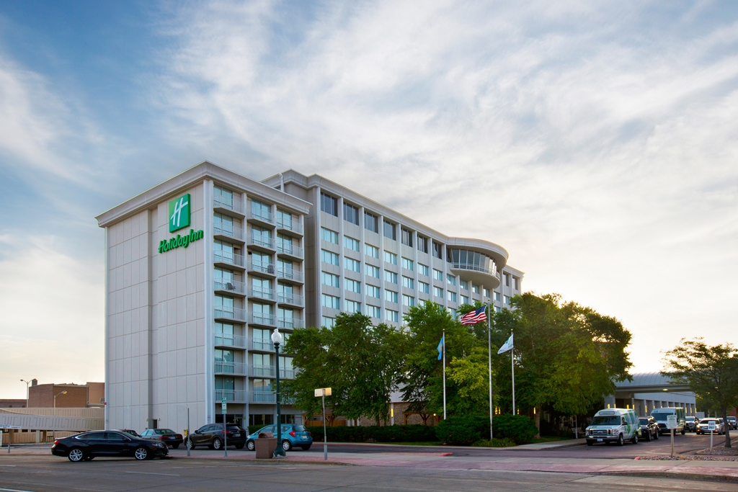
South Dakota Association of
Nurse Anesthetists
2020 Annual Fall Education Conference

September 11-12, 2020
Holiday Inn City Centre
Sioux Falls, SD
The SDANA is offering this conference FREE of charge to those register by August 28th. (Since the registration is free a donation to the PAC would be appreciated). Registrations received after August 28th will need to pay $150. Our normal registration fee is $425. Register online or mail the attached registration form to: SDANA, 617 Stumer Road, Rapid City, SD 57701 | Make checks payable to South Dakota Association of Nurse Anesthetists (SDANA)
- If paying by credit card, please use the online registration, which is now open! Please note: when paying online there is a $1.00 processing fee from Stripe.
Hotel Information:
Holiday Inn City Centre
100 W 8th Street
Sioux Falls, SD 57104
Telephone: 605-339-2000 (Reference SDANA to receive special rate by August 31st)
- - - - - - - - - - - - - - - - - - - - - - - - - - - - - - - - - - - - - - - - - - - - - - - - - - - - - - - - - - - - - - - - - - - - - - - - - - - - - - - -
Registration Rates
- Free: Registration prior to August 28, 2020
- $150 Registration after August 28, 2020
Name: _______________________________________
Address: ______________________________________
City: _________________ State: _____ Zip:__________
Email: ________________________________________
AANA Number: _________________________________
Conference Schedule
Friday, September 11th  (All times are Central Standard Time)  1700-1730 Registration and Hors d’ oeuvres  1730-1830 Dr. Michael J. Anderson, DNP, CRNA, ARNP  Anesthesia for Elective Plastic Surgery  1830-1930 Mark Haffey, MSN, CRNA, APRN  19:30-20:00 Break  2000-2100 Dr. Michael J. Anderson, DNP, CRNA, ARNP  Considerations for Specific Neurosurgical Cases  Saturday, September 12th  0730-0830 Breakfast  0730-0830 Dr. Michael J. Anderson, DNP, CRNA, ARNP  Anesthesia Infection Control  0830-0930 Barry Degan, MS, CRNA  SDANA Bylaws Review and Update, a Round Table Discussion  0930-1000 Vendor Break  1000-1100 Dustin Delaney, CRNA, NSPM-c  Education for Non-Surgical Pain Management  1100-1200 Dustin Delaney, CRNA, NSPM-c  Interventional Pain Management Therapies  1200-1330 Lunch and Business Meeting  1330-1430 Dr. Michael J. Anderson, DNP, CRNA, ARNP  AANA Update  1430-1500 Vendor Break | Saturday, September 12th cont’d  1500-1600 Linda Young, MS, RN, FRE  Executive Director, South Dakota Board of Nursing  1600-1700 Mark Haffey, MSN, CRNA, APRN  Making the Choice: Current Trends in Intra-Op Pain Management  1700-2200 PAC Event  This program has been approved by the AANA for 10 CE credits and 3 Pharm credits  The program evaluation will be sent via email by Wednesday, September 16th. Please complete within 30 days to receive credits.  